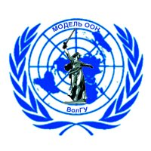**ВОЛГОГРАДСКАЯ МОДЕЛЬ ООН 2011**

**VOLGOGRAD MODEL UN 2011**

**22-25 ноября**

**22-25 November**

400062, проспект Университетский, 100, 100, Universitetsky Prospect, 400062,

Волгоград, Россия Volgograd, Russia

Тел.: (8442) 460-279 tel.: (8442) 460-279,

e-mail: modelunvlg@gmail.com e-mail: modelunvlg@gmail.com

**Informational Letter**

We kindly inform you that the research and practice student conference Volgograd Model UN will take place in the Volgograd State University from 22 till 25 November 2011.

The Volgograd Model UN is organized collaboratively with secretariats of leading Russian Models UN: Moscow International Model UN (MGIMO – University) and Moscow Russian State University for the Humanities Model UN.

The Model Un is a combination of a scientific conference and a role play, where university and high school students simulate the work of different UN bodies. When participating in MIMUN students gain diplomatic, leadership and public speaking skills, master their knowledge of foreign languages and learn to compromise. The working languages of the Model UN are Russian, English and French.

We invite your students to participate in Volgograd State University Model UN 2011.

Sincerely, Taisya Yudina

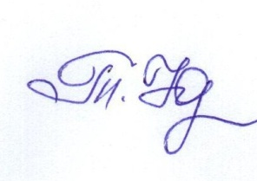

Educational vice-rector

**Appendix 1**

**The Volgograd Model UN Agenda**

|  |  |  |  |
| --- | --- | --- | --- |
| **Body** | **Agenda** | **Number of countries** | **Working language** |
| ECOSOS | The problem of unemployment as a key factor on world economic stability | 54 | English |
| Human Rights Council | International cooperation in preventing genocide | 46 | Russian |
| 1st Committee of the General Assembly | Measures to international terrorism elimination | 61 | Russian |
| Security Council | Situation in Libya (La situation en Jamahiriya arabe libyenne) | 15 | French |

For participating to the conference it is necessary to fill the application form including the essay on the agenda discussed in the body. The essay should be presented in the working language of the body. **The quality of the essay is the main factor on distributing countries.**

The filled application form should be sent to Secretariat e-mail: [**modelunvlg@gmail.com**](mailto:modelunvlg@gmail.com)**.**

For additional information participants and interested parties can address to the Model UN Secretariat at the e-mail mentioned above.